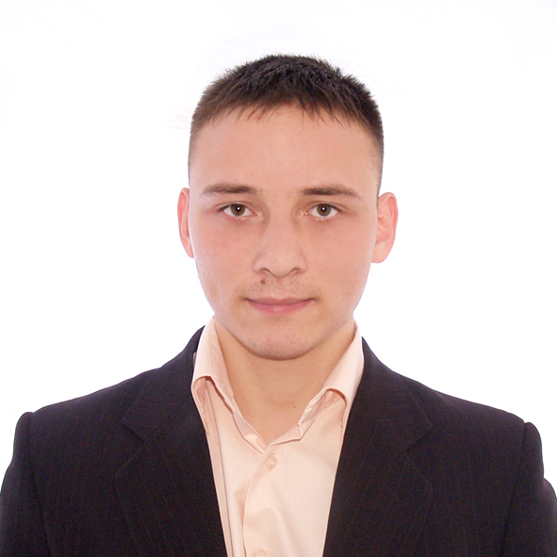
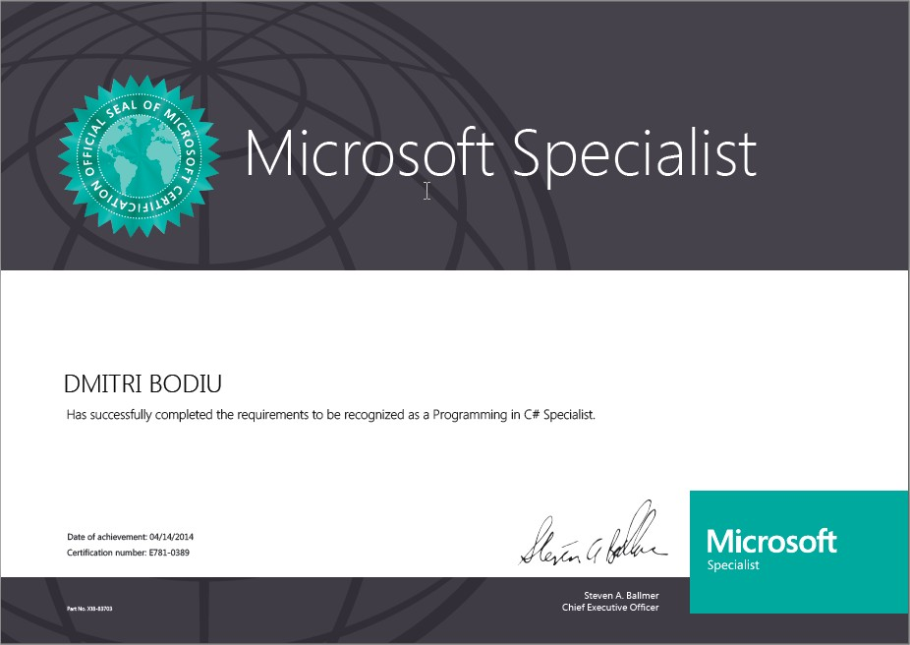
Bodiu Dmitri
________________________________________________________________________________
MS .NET Developer
Email: dmitribodiu1989@gmail.com
Mob: (MD) +373 69 95 35 95
Address: (MD) Chisinau, Moldova
Birth: 10-31-1989

Objective
________________________________________________________________________________
Web applications developer (ASP.NET MVC, WebForms, and Silverlight)
Windows applications developer (WPF, WinForms)
Database applications developer (SQL, Entity framework)
WCF/Web services developer (WCF, WebAPI)

Summary
________________________________________________________________________________Microsoft certified (Programming in C#) .NET developer with 2 years of experience in development of multi-tier database-driven systems. I have experience of working in the international company’s team on complex enterprise applications. Always eager to professional grow and solve diverse problems.

Key skills
________________________________________________________________________________
Core skills
NET 4.5, C#, LINQ, SQL, XML, XAML, Multithreading, Design Patterns, MVC, MVVM, OOP, UML, Unit Testing, Dependency Injection, SOLID principles.
Web development
ASP.NET MVC 4.0, Silverlight, Azure, HTML, CSS, JavaScript, Ajax, JQuery, WCF, XML/SOAP, IIS, AngularJS, Bootstrap, TypeScript, Web API, OWIN, OAuth2
Windows Development
WPF, WinForms
Databases
Ms SQL Server, Oracle, ADO.Net, Entity Framework, Linq to Sql
IDE, Components, Versions of Control
Visual Studio 2012, 2013, JTable plugin, Ninject, Mercurial, SVN, Git (SourceTree), AutoFac, Castle Windsor, NodaTime, AutoMapper

Education
________________________________________________________________________________

Faculty: IT (Software Development and Programming) 2009-2013
University: State University of Moldova

Work experience
________________________________________________________________________________

October 2014 – Present
.NET developer at JivyGroup

September 2013 – October 2014
.NET developer at Cedacri International

May 2012 – September 2012
Waiter at the Lobster House, USA, Cape May, NJ.

May 2011 – September 2011
Room attendant at the Sandpiper Beach Club, USA, Cape May, NJ, 08204

September 2008 – September 2012
Pre-paid tutor of Russian & Romanian languages, Mathematics, Physics.

Languages
________________________________________________________________________________
English (Fluent),
Romanian (Fluent),
French (Beginner),
Italian (Beginner),
Russian (Native)

